**ITSE 1330 – Intro to C#**

**Module 1 - Project 1**

**There are 2 projects for this Module. Place both project folders in a folder called FirstnameLastnameCSMod1. When you are done with both, zip the folder and submit via Moodle. DO NOT ZIP EACH INDIVIDUAL PROJECT, only the outer folder.**

*Create a Windows Forms application named* ***FirstNameLastName1A***

*Save the application in the FirstnameLastnameCSMod1 folder.*

Create a project that translates the French words to English. The form should have 3 buttons, 1 for each French word. When the user clicks a button, the application should display the English translation in a single label control.

**French**  **English**

la gauche left

milieu middle

droit right

Example Form:

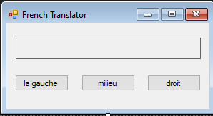

*Create a Windows Forms application named* ***FirstNameLastName1B***

*Save the application in the FirstnameLastnameCSMod1 folder.*

Create an application that has a label and 2 buttons on a form. One of the buttons should read Joke and the other should read Punch Line. When the joke button is clicked, display the joke in the label. When the punch line button is clicked, display the joke’s punch line in the label. Keep the jokes clean please 😊

Example Form:

